QUESTION:
Lab 3: Create a database called library_db and a table books with columns: book_id, title, author, publisher, year_of_publication, and price. Insert five records into the table.
CODE:
CREATE DATABASE library_db;
CREATE TABLE books (
book_id INT PRIMARY KEY,
title VARCHAR(100),
author VARCHAR(100),
publisher VARCHAR(100),
year_of_publication INT,
price DECIMAL(10,2)
);
INSERT INTO books (book_id, title, author, publisher, year_of_publication, price)
VALUES
(1, 'Introduction to SQL', 'James Smith', 'TechPress', 2018, 450.00),
(2, 'Database Management Systems', 'Navathe', 'Pearson', 2016, 650.00),
(3, 'Learning Python', 'Mark Lutz', 'OReilly', 2015, 799.00),
(4, 'Web Development Guide', 'John Doe', 'WebBooks', 2020, 550.00),
(5, 'Advanced Java Programming', 'Herbert Schildt', 'McGraw Hill', 2019, 700.00);
SCREENSHOT:
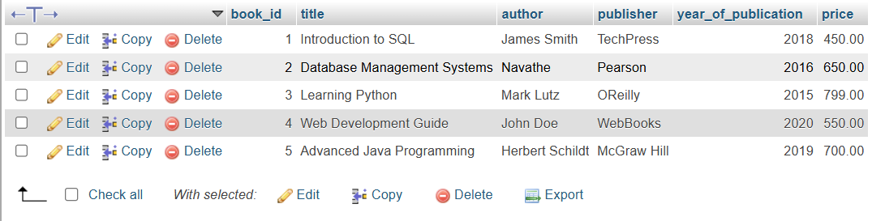

QUESTION:
Lab 4: Create a table members in library_db with columns: member_id, member_name, date_of_membership, and email. Insert five records into this table.
CODE:
CREATE TABLE members (
member_id INT PRIMARY KEY,
member_name VARCHAR(100),
date_of_membership DATE,
email VARCHAR(100)
);
INSERT INTO members (member_id, member_name, date_of_membership, email)
VALUES
(1, 'Rahul Sharma', '2022-01-15', 'rahul.sharma@example.com'),
(2, 'Priya Patel', '2021-12-20', 'priya.patel@example.com'),
(3, 'Amit Kumar', '2023-03-05', 'amit.kumar@example.com'),
(4, 'Sneha Mehta', '2022-07-10', 'sneha.mehta@example.com'),
(5, 'Karan Joshi', '2023-01-25', 'karan.joshi@example.com');

SCREENSHOT:

QUESTION:
Lab 3: Retrieve all members who joined the library before 2022. Use appropriate SQL syntax with WHERE and ORDER BY.
CODE:
SELECT *
FROM members
WHERE date_of_membership < '2022-01-01'
ORDER BY date_of_membership ASC;

SCREENSHOT:

QUESTION:
Lab 4: Write SQL queries to display the titles of books published by a specific author. Sort the results by year_of_publication in descending order.

CODE:
SELECT title, author, year_of_publication
FROM books
WHERE author = 'Mark Lutz'
ORDER BY year_of_publication DESC;

SCREENSHOT:
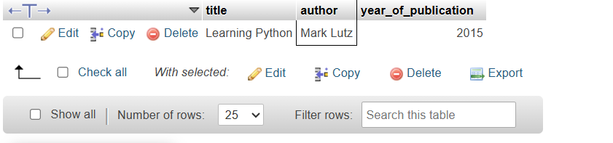

QUESTION:
Lab 3: Add a CHECK constraint to ensure that the price of books in the books table is greater than 0.
CODE:
ALTER TABLE books
ADD CONSTRAINT chk_price CHECK (price > 0);

SCREENSHOT:
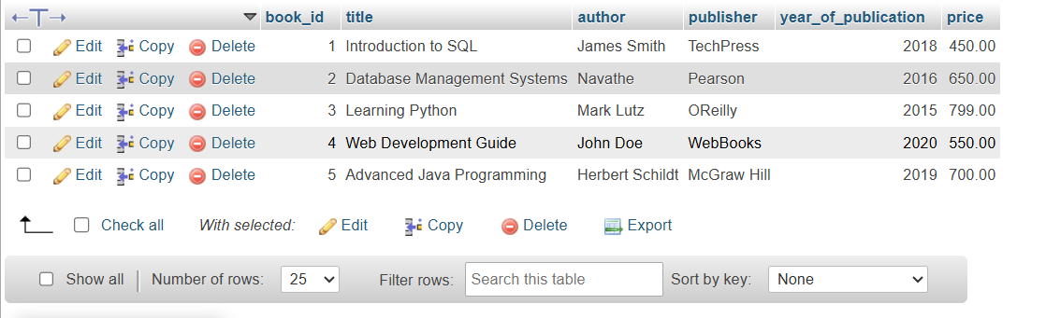

QUESTION:
Lab 4: Modify the members table to add a UNIQUE constraint on the email column, ensuring that each member has a unique email address.
CODE:
ALTER TABLE members
ADD CONSTRAINT unique_email UNIQUE (email);

SCREENSHOT:
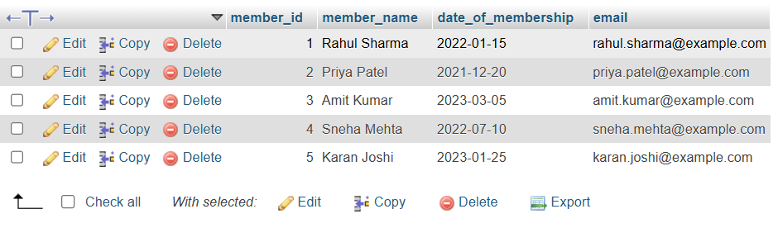

QUESTION:
Lab 3: Create a table authors with the following columns: author_id, first_name, last_name, and country. Set author_id as the primary key.
CODE:
CREATE TABLE authors (
author_id INT PRIMARY KEY,
first_name VARCHAR(100),
last_name VARCHAR(100),
country VARCHAR(100)
);

SCREENSHOT:
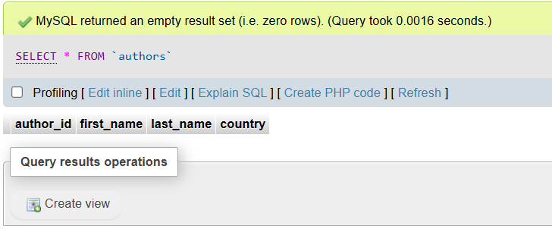

QUESTION:
Lab 4: Create a table publishers with columns: publisher_id, publisher_name, contact_number, and address. Set publisher_id as the primary key and contact_number as unique.

CODE:
CREATE TABLE publishers (
publisher_id INT PRIMARY KEY,
publisher_name VARCHAR(150),
contact_number VARCHAR(20) UNIQUE,
address VARCHAR(200)
);
SCREENSHOT:
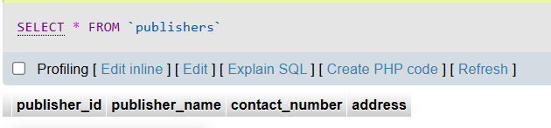

QUESTION:
Lab 3: Add a new column genre to the books table. Update the genre for all existing records.

CODE:
ALTER TABLE books
ADD genre VARCHAR(50);
UPDATE books
SET genre = 'Education'
WHERE book_id = 1;

UPDATE books
SET genre = 'Technology'
WHERE book_id = 2;

UPDATE books
SET genre = 'Programming'
WHERE book_id = 3;

UPDATE books
SET genre = 'Web Development'
WHERE book_id = 4;

UPDATE books
SET genre = 'Java'
WHERE book_id = 5;

SCREENSHOT:
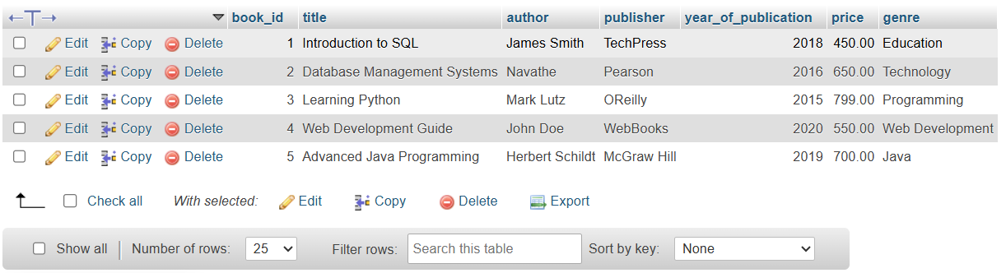

QUESTION:
Lab 4: Modify the members table to increase the length of the email column to 100 characters.
CODE:
ALTER TABLE members
MODIFY email VARCHAR(100);

SCREENSHOT:
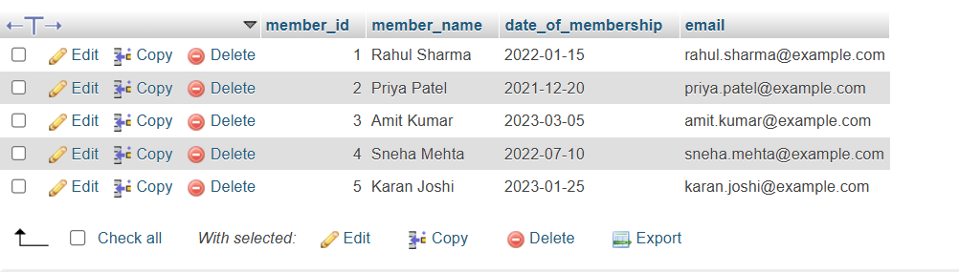

QUESTION:
Lab 3: Drop the publishers table from the database after verifying its structure.
CODE:
DROP TABLE publishers;

SCREENSHOT:
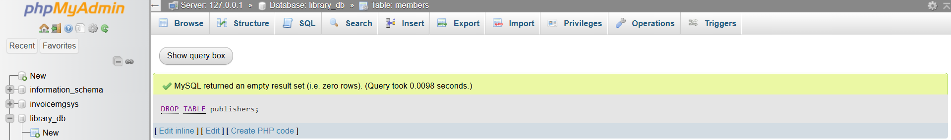

QUESTION:
Lab 4: Create a backup of the members table and then drop the original members table.
CODE:
CREATE TABLE members_backup AS
SELECT * FROM members;
DROP TABLE members;

SCREENSHOT:
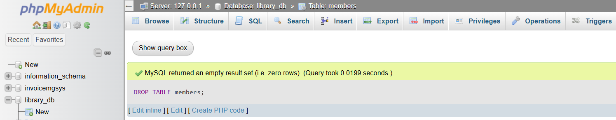

QUESTION:
Lab 4: Insert three new authors into the authors table, then update the last name of one of the authors.
CODE:
INSERT INTO authors (author_id, first_name, last_name, country)
VALUES
(1, 'Robert', 'Martin', 'USA'),
(2, 'Ken', 'Thompson', 'USA'),
(3, 'Dennis', 'Ritchie', 'USA');

UPDATE authors
SET last_name = 'Richards'
WHERE author_id = 3;

SCREENSHOT:
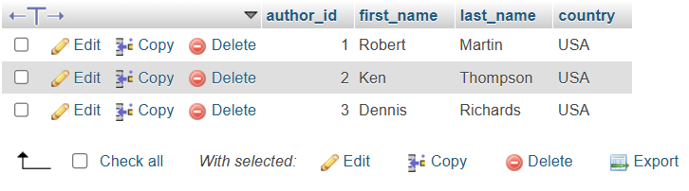

QUESTION:
Lab 5: Delete a book from the books table where the price is higher than $100.
CODE:
DELETE FROM books
WHERE price > 100;

SCREENSHOT:
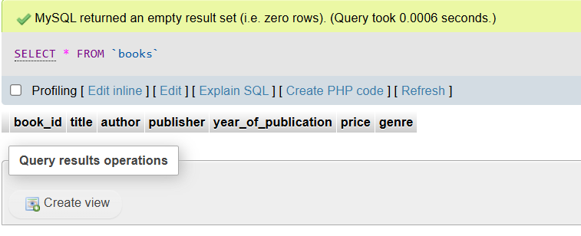

QUESTION:
Lab 3: Update the year_of_publication of a book with a specific book_id.
CODE:
UPDATE books
SET year_of_publication = 2021
WHERE book_id = 3;

SCREENSHOT:
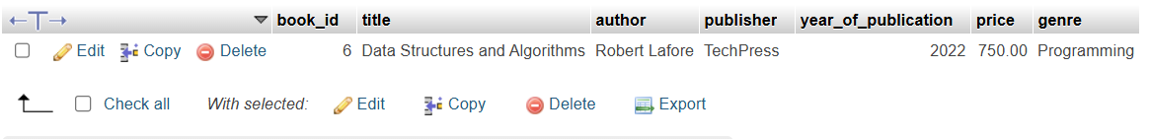

QUESTION:
Lab 4: Increase the price of all books published before 2015 by 10%.
CODE:
UPDATE books
SET price = price * 1.10
WHERE year_of_publication < 2015;

SCREENSHOT:
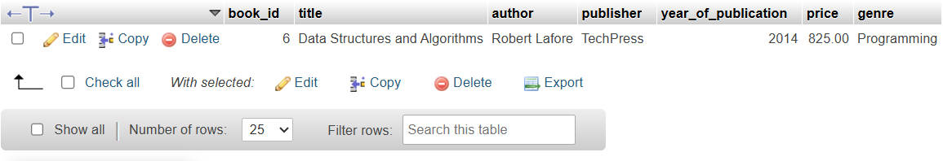

QUESTION:
Lab 3: Remove all members who joined before 2020 from the members table.
CODE:
DELETE FROM members_backup
WHERE date_of_membership < '2020-01-01';

SCREENSHOT:
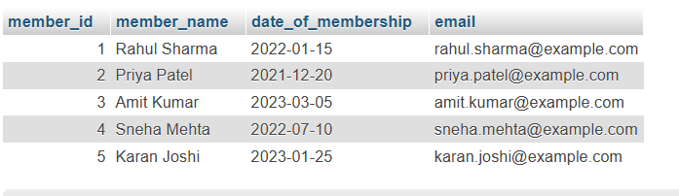

QUESTION:
Lab 4: Delete all books that have a NULL value in the author column.
CODE:
DELETE FROM books
WHERE author IS NULL;

SCREENSHOT:
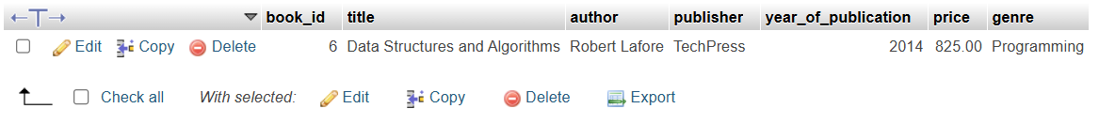

QUESTION:
Lab 4: Write a query to retrieve all books with price between $50 and $100.
CODE:
SELECT *
FROM books
WHERE price BETWEEN 50 AND 100;

SCREENSHOT:

QUESTION:
Lab 5: Retrieve the list of books sorted by author in ascending order and limit the results to the top 3 entries.
CODE:
SELECT *
FROM books
ORDER BY author ASC
LIMIT 3;

SCREENSHOT:
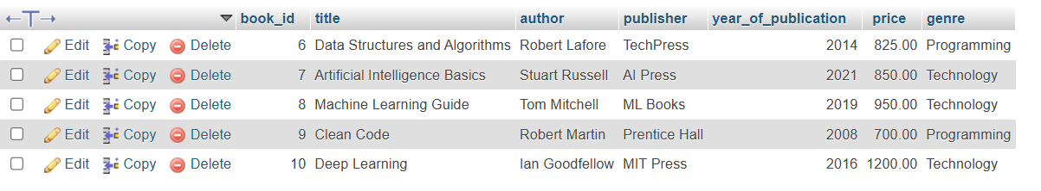

QUESTION:
Lab 3: Grant SELECT permission to a user named librarian on the books table.
CODE:
GRANT SELECT ON books TO 'librarian'@'localhost';

SCREENSHOT:
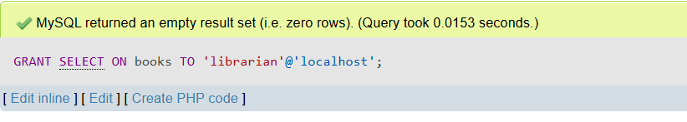

QUESTION:
Lab 4: Grant INSERT and UPDATE permissions to the user admin on the members table.
CODE:
GRANT INSERT, UPDATE ON members TO 'admin'@'localhost';

SCREENSHOT:
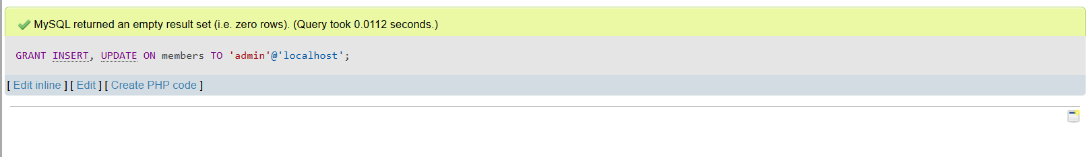

QUESTION:
Lab 3: Revoke the INSERT privilege from the user librarian on the books table.
CODE:
REVOKE INSERT ON books FROM 'librarian'@'localhost';

SCREENSHOT:
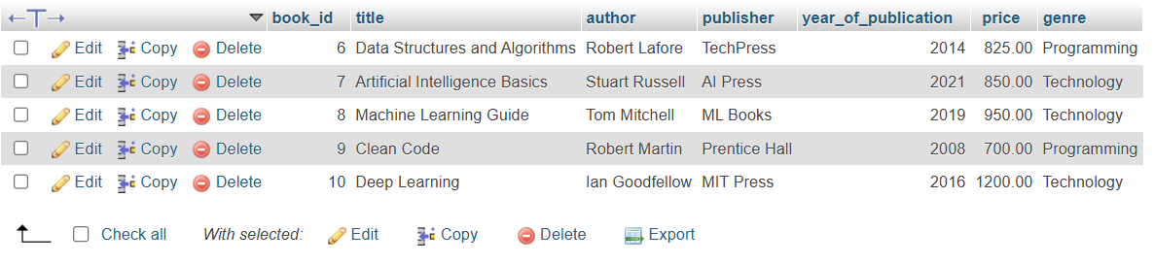

QUESTION:
Lab 4: Revoke all permissions from user admin on the members table.
CODE:
REVOKE ALL PRIVILEGES ON members FROM 'admin'@'localhost';

SCREENSHOT:
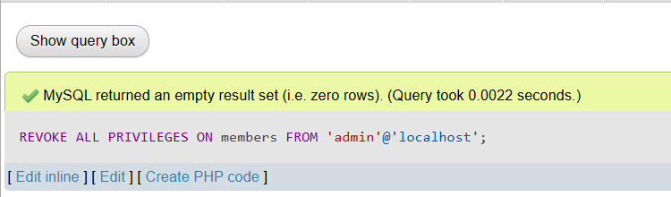

QUESTION:
Lab 3: Use COMMIT after inserting multiple records into the books table, then make another insertion and perform a ROLLBACK.
CODE:
START TRANSACTION;
INSERT INTO books (book_id, title, author, publisher, year_of_publication, price, genre)
VALUES
(14, 'Cloud Computing Basics', 'Thomas Erl', 'TechWorld', 2020, 700.00, 'Technology');
ROLLBACK;
SCREENSHOT:
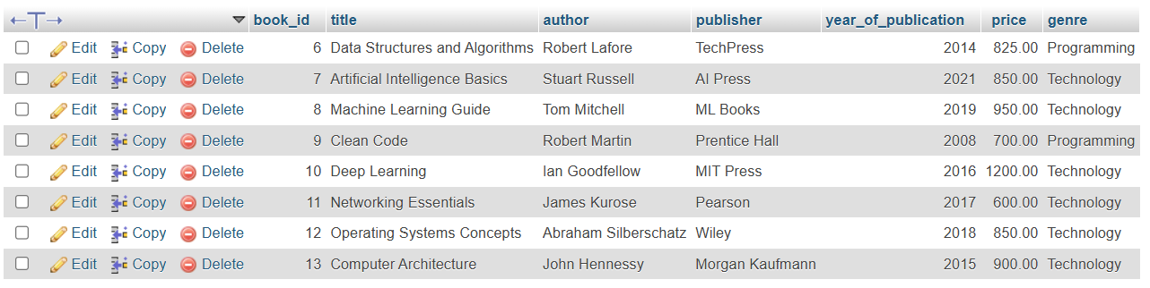

QUESTION:
Lab 4: Set a SAVEPOINT before making updates to the members table, perform some updates, and then roll back to the SAVEPOINT.
CODE:
START TRANSACTION;
SAVEPOINT sp1;
UPDATE members
SET member_name = 'Rahul S.'
WHERE member_id = 1;
UPDATE members
SET email = 'updated.priya@example.com'
WHERE member_id = 2;
ROLLBACK TO SAVEPOINT sp1;
COMMIT;

SCREENSHOT:
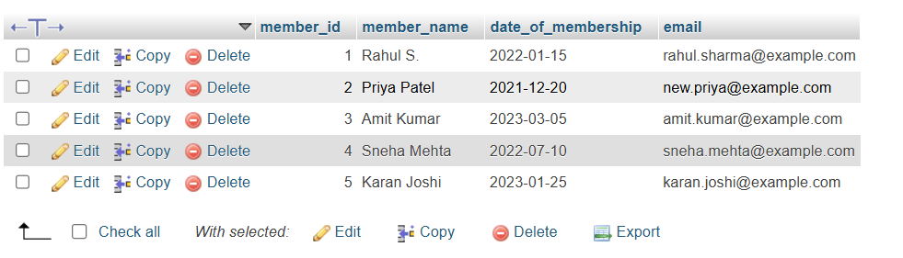
QUESTION:
Lab 3: Perform an INNER JOIN between books and authors tables to display the title of books and their respective authors' names.
CODE:
SELECT
books.title,
authors.first_name,
authors.last_name
FROM books
INNER JOIN authors
ON books.author = CONCAT(authors.first_name, ' ', authors.last_name);

SCREENSHOT:

QUESTION:
Lab 4: Use a FULL OUTER JOIN to retrieve all records from the books and authors tables, including those with no matching entries in the other table.
CODE:
SELECT
books.title,
authors.first_name,
authors.last_name
FROM books
LEFT JOIN authors
ON books.author = CONCAT(authors.first_name, ' ', authors.last_name)

UNION

SELECT
books.title,
authors.first_name,
authors.last_name
FROM books
RIGHT JOIN authors
ON books.author = CONCAT(authors.first_name, ' ', authors.last_name);
SCREENSHOT:
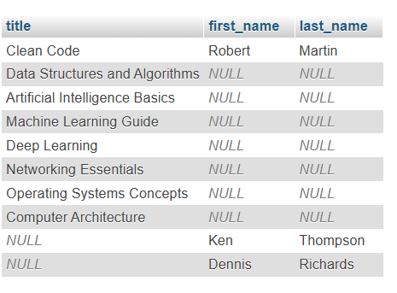

QUESTION:
Lab 3: Group books by genre and display the total number of books in each genre.
CODE:
SELECT genre,COUNT(*) AS total_books
FROM books
GROUP BY genre;

SCREENSHOT:
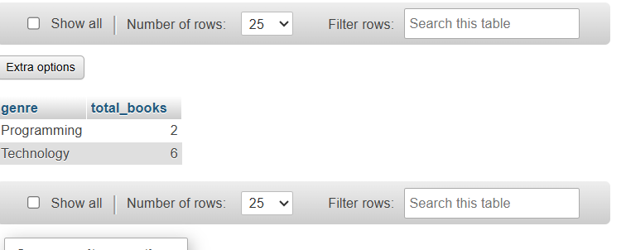

QUESTION:
Lab 4: Group members by the year they joined and find the number of members who joined each year.
CODE:
SELECT YEAR(date_of_membership) AS join_year,COUNT(*) AS total_members
FROM members
GROUP BY YEAR(date_of_membership);
SCREENSHOT:
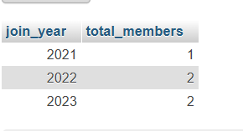
QUESTION:
Lab 3: Write a stored procedure to retrieve all books by a particular author.
CODE:
DELIMITER //
CREATE PROCEDURE getBooksByAuthor(IN authorName VARCHAR(100))
BEGIN
SELECT * FROM books WHERE author=authorName;
END //
DELIMITER ;

SCREENSHOT:
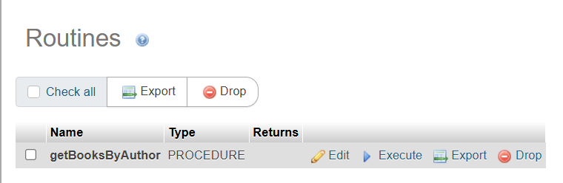

QUESTION:
Lab 4: Write a stored procedure that takes book_id as an argument and returns the price of the book.
CODE:

DELIMITER //
CREATE PROCEDURE getBookPrice(IN bid INT)
BEGIN
SELECT price FROM books WHERE book_id=bid;
END //
DELIMITER ;
SCREENSHOT:
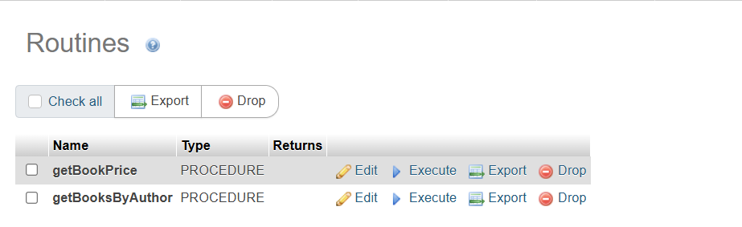

QUESTION:
Lab 3: Create a view to show only the title, author, and price of books from the books table.
CODE:
CREATE VIEW books_view AS
SELECT title,author,price
FROM books;

SCREENSHOT:
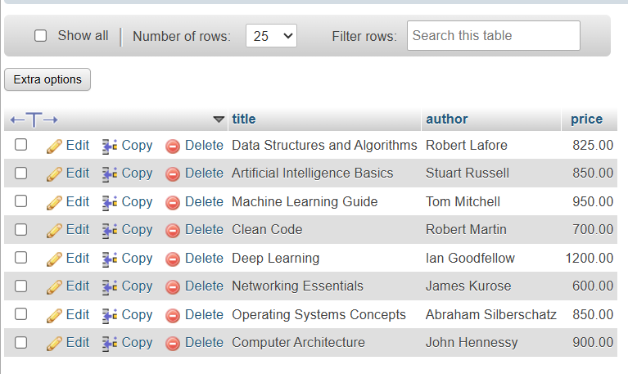

QUESTION:
Lab 4: Create a view to display members who joined before 2020.
CODE:
CREATE VIEW members_before_2020 AS
SELECT *
FROM members
WHERE date_of_membership<'2020-01-01';

SCREENSHOT:
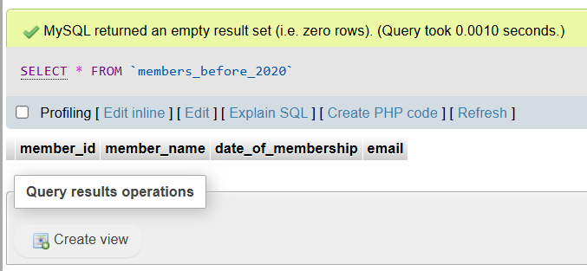

QUESTION:
Lab 3: Create a trigger to automatically update the last_modified timestamp of the books table whenever a record is updated.
CODE:
DELIMITER //
CREATE TRIGGER update_last_modified
BEFORE UPDATE ON books
FOR EACH ROW
BEGIN
SET NEW.last_modified=CURRENT_TIMESTAMP;
END //DELIMITER ;
SCREENSHOT:
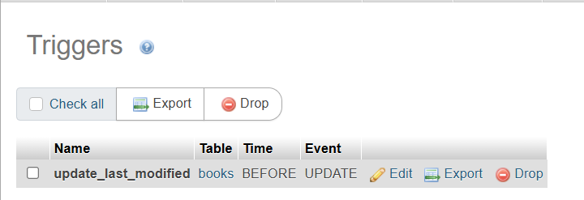

QUESTION:
Lab 4: Create a trigger that inserts a log entry into a log_changes table whenever a DELETE operation is performed on the books table.
CODE:
DELIMITER //
CREATE TRIGGER log_book_deletion
AFTER DELETE ON books
FOR EACH ROW
BEGIN
INSERT INTO log_changes(book_id,title,deleted_at)
VALUES(OLD.book_id,OLD.title,CURRENT_TIMESTAMP);
END //
DELIMITER ;

SCREENSHOT:
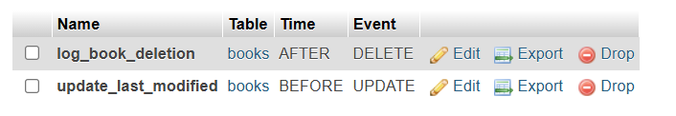

QUESTION:
Lab 3: Write a PL/SQL block to insert a new book into the books table and display a confirmation message.
CODE:
DELIMITER //

CREATE PROCEDURE insertBook()
BEGIN
INSERT INTO books (book_id, title, author, publisher, year_of_publication, price, genre)
VALUES (15,'Python Programming','Mark Lutz','OReilly',2023,800.00,'Programming');
SELECT 'Book inserted successfully.' AS message;
END //

DELIMITER ;

SCREENSHOT:
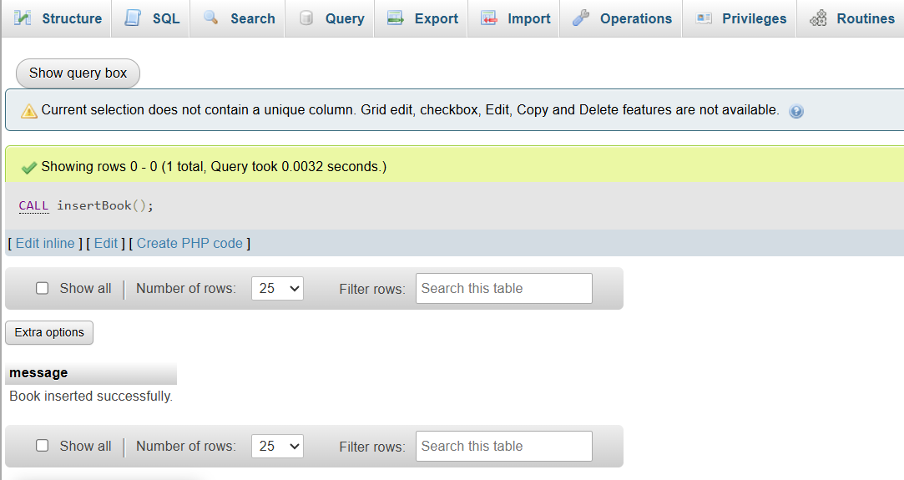

QUESTION:
Lab 4: Write a PL/SQL block to display the total number of books in the books table.
CODE:
DELIMITER //

CREATE PROCEDURE getTotalBooks()
BEGIN
SELECT COUNT(*) AS total_books FROM books;
END //

DELIMITER ;

SCREENSHOT:
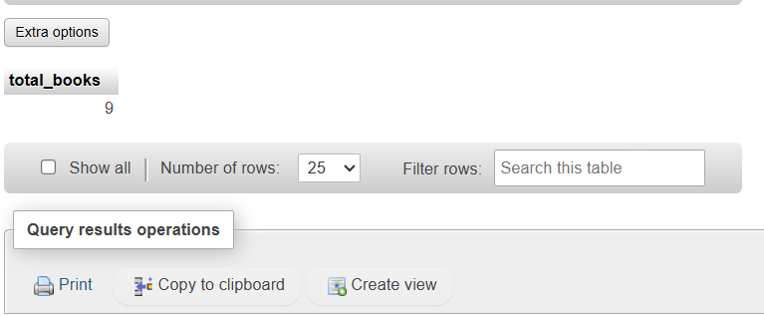

QUESTION:
Lab 3: Write a PL/SQL block to declare variables for book_id and price, assign values, and display the results.
CODE:
DELIMITER //

CREATE PROCEDURE showBookInfo()
BEGIN
DECLARE v_book_id INT;
DECLARE v_price DECIMAL(10,2);

SET v_book_id = 101;
SET v_price = 499.99;

SELECT v_book_id AS book_id, v_price AS price;
END //
DELIMITER ;

SCREENSHOT:
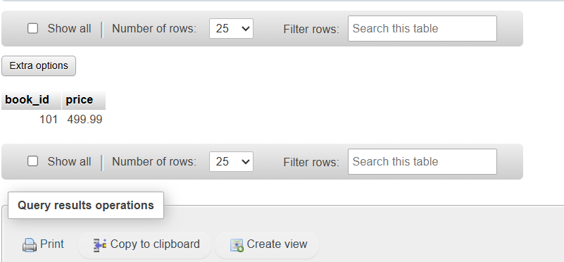
QUESTION:
Lab 4: Write a PL/SQL block using constants and perform arithmetic operations on book prices.
CODE:
DELIMITER //

CREATE PROCEDURE priceOperations()
BEGIN
DECLARE CONST_DISCOUNT DECIMAL(5,2) DEFAULT 50.00;
DECLARE total_price DECIMAL(10,2);
SELECT SUM(price) INTO total_price FROM books;
SELECT total_price AS original_total,
CONST_DISCOUNT AS discount,
(total_price - CONST_DISCOUNT) AS discounted_total;
END //
DELIMITER ;

SCREENSHOT:
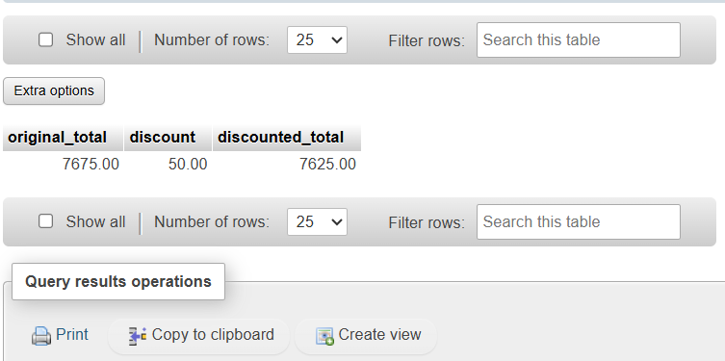

QUESTION:
Lab 3: Write a PL/SQL block using IF-THEN-ELSE to check if a book's price is above $100 and print a message accordingly.
CODE:
DELIMITER //

CREATE PROCEDURE checkBookPrice(IN bid INT)
BEGIN
DECLARE book_price DECIMAL(10,2);
SELECT price INTO book_price FROM books WHERE book_id = bid;
IF book_price > 100 THEN
SELECT CONCAT('Book ID ', bid, ' has a price above $100') AS message;
ELSE
SELECT CONCAT('Book ID ', bid, ' has a price $100 or below') AS message;
END IF;
END //
DELIMITER ;

SCREENSHOT:
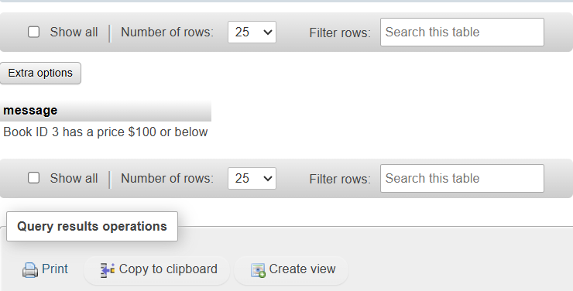
QUESTION:
Lab 4: Use a FOR LOOP in PL/SQL to display the details of all books one by one.
CODE:
DELIMITER //
CREATE PROCEDURE displayBooksForLoop()
BEGIN
DECLARE done INT DEFAULT 0;
DECLARE v_book_id INT;
DECLARE v_title VARCHAR(255);
DECLARE v_author VARCHAR(100);
DECLARE v_publisher VARCHAR(100);
DECLARE v_year INT;
DECLARE v_price DECIMAL(10,2);
DECLARE v_genre VARCHAR(50);
DECLARE cur_books CURSOR FOR
SELECT book_id, title, author, publisher, year_of_publication, price, genre FROM books;
DECLARE CONTINUE HANDLER FOR NOT FOUND SET done = 1;
OPEN cur_books;
read_loop: LOOP
FETCH cur_books INTO v_book_id, v_title, v_author, v_publisher, v_year, v_price, v_genre;
IF done THEN
LEAVE read_loop;
END IF;
SELECT v_book_id AS book_id, v_title AS title, v_author AS author, v_publisher AS publisher, v_year AS year_of_publication, v_price AS price, v_genre AS genre;
END LOOP;
CLOSE cur_books;
END //DELIMITER ;
SCREENSHOT:
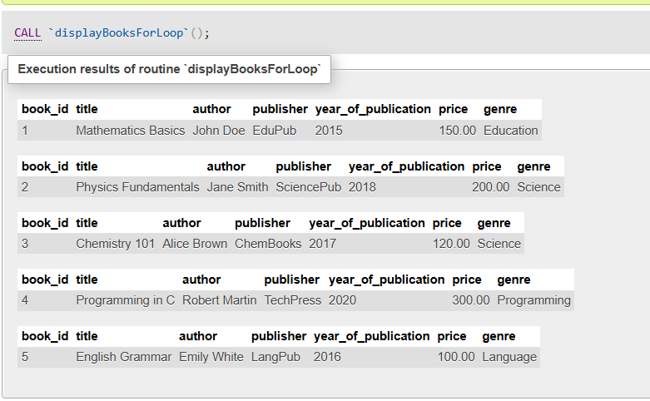

QUESTION:
Lab 3: Write a PL/SQL block using an explicit cursor to fetch and display all records from the members table.
CODE:
DELIMITER //
CREATE PROCEDURE displayMembers()
BEGIN
DECLARE done INT DEFAULT 0;
DECLARE v_member_id INT;
DECLARE v_member_name VARCHAR(100);
DECLARE v_date_of_membership DATE;
DECLARE v_email VARCHAR(100);
DECLARE cur_members CURSOR FOR
SELECT member_id, member_name, date_of_membership, email FROM members;
DECLARE CONTINUE HANDLER FOR NOT FOUND SET done = 1;
OPEN cur_members;
read_loop: LOOP
FETCH cur_members INTO v_member_id, v_member_name, v_date_of_membership, v_email;
IF done THEN
LEAVE read_loop;
END IF;
SELECT v_member_id AS member_id, v_member_name AS member_name, v_date_of_membership AS date_of_membership, v_email AS email;
END LOOP;
CLOSE cur_members;
END //
DELIMITER ;

SCREENSHOT:
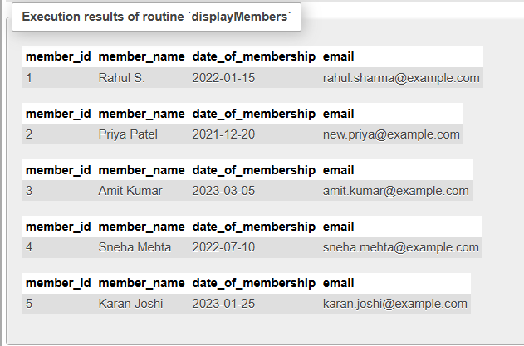

QUESTION:
Lab 4: Create a cursor to retrieve books by a particular author and display their titles.
CODE:
DELIMITER //
CREATE PROCEDURE getBooksByAuthorCursor(IN authorName VARCHAR(100))
BEGIN
DECLARE done INT DEFAULT 0;
DECLARE v_title VARCHAR(255);
DECLARE cur_books CURSOR FOR
SELECT title FROM books WHERE author = authorName;
DECLARE CONTINUE HANDLER FOR NOT FOUND SET done = 1;
OPEN cur_books;
read_loop: LOOP
FETCH cur_books INTO v_title;
IF done THEN
LEAVE read_loop;
END IF;
SELECT v_title AS title;
END LOOP;
CLOSE cur_books;
END //
DELIMITER ;
SCREENSHOT:
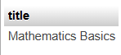

QUESTION:
Lab 3: Perform a transaction that includes inserting a new member, setting a SAVEPOINT, and rolling back to the savepoint after making updates.
CODE:
START TRANSACTION;
INSERT INTO members (member_id, member_name, date_of_membership, email)
VALUES (6, 'Amit Sharma', '2023-05-10', 'amit.sharma@example.com');
SAVEPOINT sp_before_update;
UPDATE members
SET member_name = 'Amit S.'
WHERE member_id = 6;
UPDATE members
SET email = 'amit.new@example.com'
WHERE member_id = 6;
ROLLBACK TO SAVEPOINT sp_before_update;
COMMIT;

SCREENSHOT:
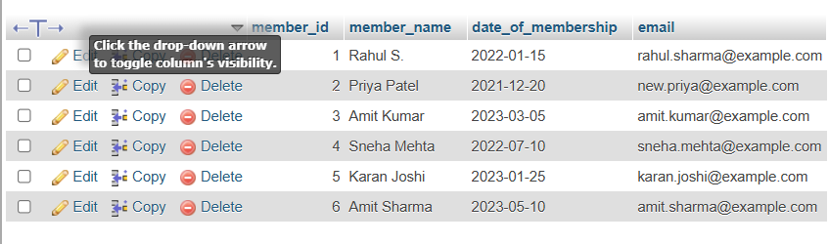

QUESTION:
Lab 4: Use COMMIT after successfully inserting multiple books into the books table, then use ROLLBACK to undo a set of changes made after a savepoint.
CODE:
START TRANSACTION;
INSERT INTO books (book_id,title,author,publisher,year_of_publication,price,genre)
VALUES
(20,'Machine Learning','John Smith','TechPress',2022,400.00,'Programming'),
(21,'Artificial Intelligence','Jane Doe','AI Pub',2021,350.00,'Programming'),
(22,'Big Data Analytics','Alice Brown','DataPub',2020,300.00,'Data Science');
COMMIT;
START TRANSACTION;
SAVEPOINT sp_before_update;
UPDATE books
SET price = price + 50
WHERE book_id IN (20,21);
ROLLBACK TO SAVEPOINT sp_before_update;
COMMIT;

SCREENSHOT:
